9-april-2022

TESTING SELENIUM

Pip— python installer package

Pip install pywin32 ----- chrome web driver update

SELENIUM WEBDRIVER ARCHITECTURE :-----

* It provides 2 way communication between browser and programming language
* It supports browsers like Firefox, chrome, safari, Edge
* The components of Web Drivers are :-
  + Programming language
  + JSON Wire Protocol –standard for exchanging data in internet
  + Browser driver
  + Real web browsers
* The script written in any programming language gets converted into JSON data and this JSON data is being transferred to the browser driver which according to the specificity of the browser hits the real web browser and does the request response cycle.
* JSON wire protocol is the industry standard for sharing JSON data on the internet using the OSI Reference Model using the HTTP-TCP/IP protocols.
* JSON + OSI Reference Model = JSON Wire Protocol

**BROWSER DRIVER**

* A request has been created using the script language using the HTTP protocol.
* The browser driver , after receiving the HTTP request decides which steps need to be taken sequentially in order to execute the HTTP request.
* When the script has been executed on the server the information is send to the script via HTTP using the request - response cycle of the OSI reference model.
* Webdrivers can support a lot of programming languages
* Webdrivers support a lot of real world browsers
* With webdriver you can do automation without opening a real browser.

<https://github.com/sgangopadhyay/AT-1-2-WE/tree/main>

XML --- Read about it

API --- read about it

JSON ---

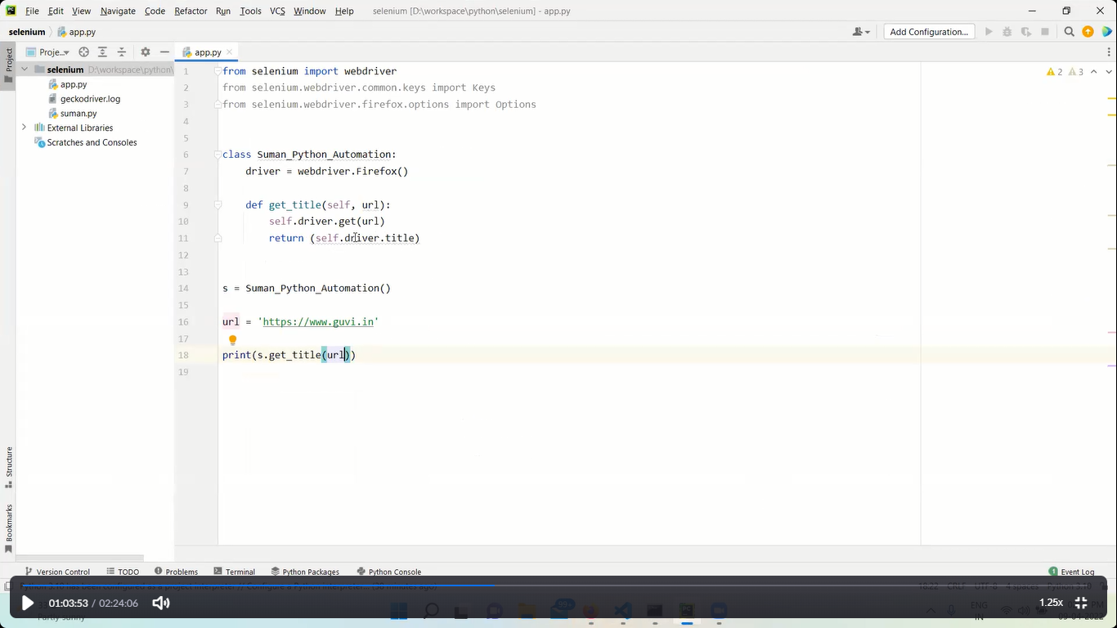

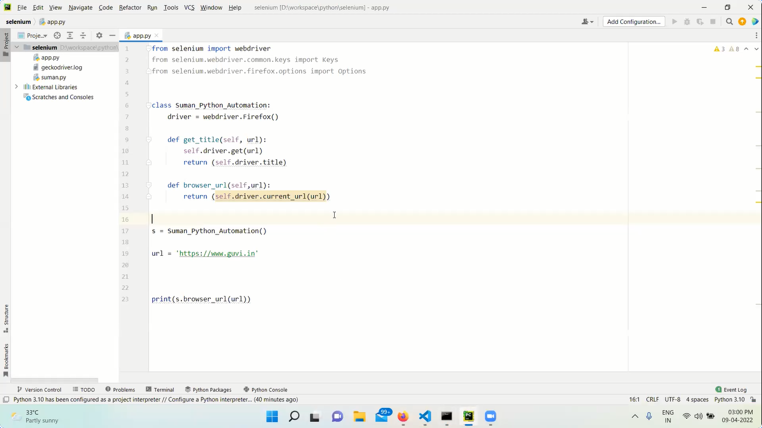

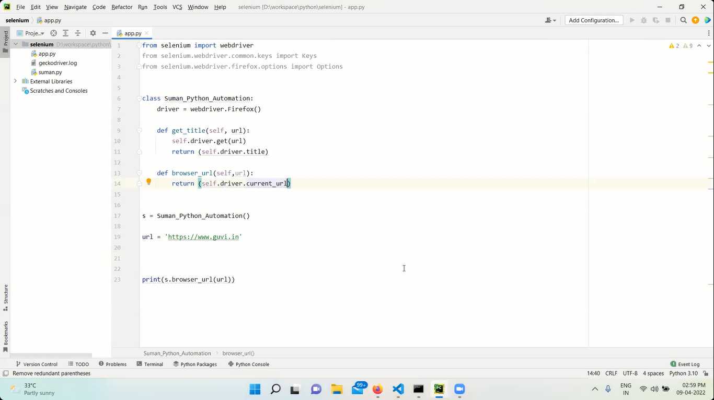

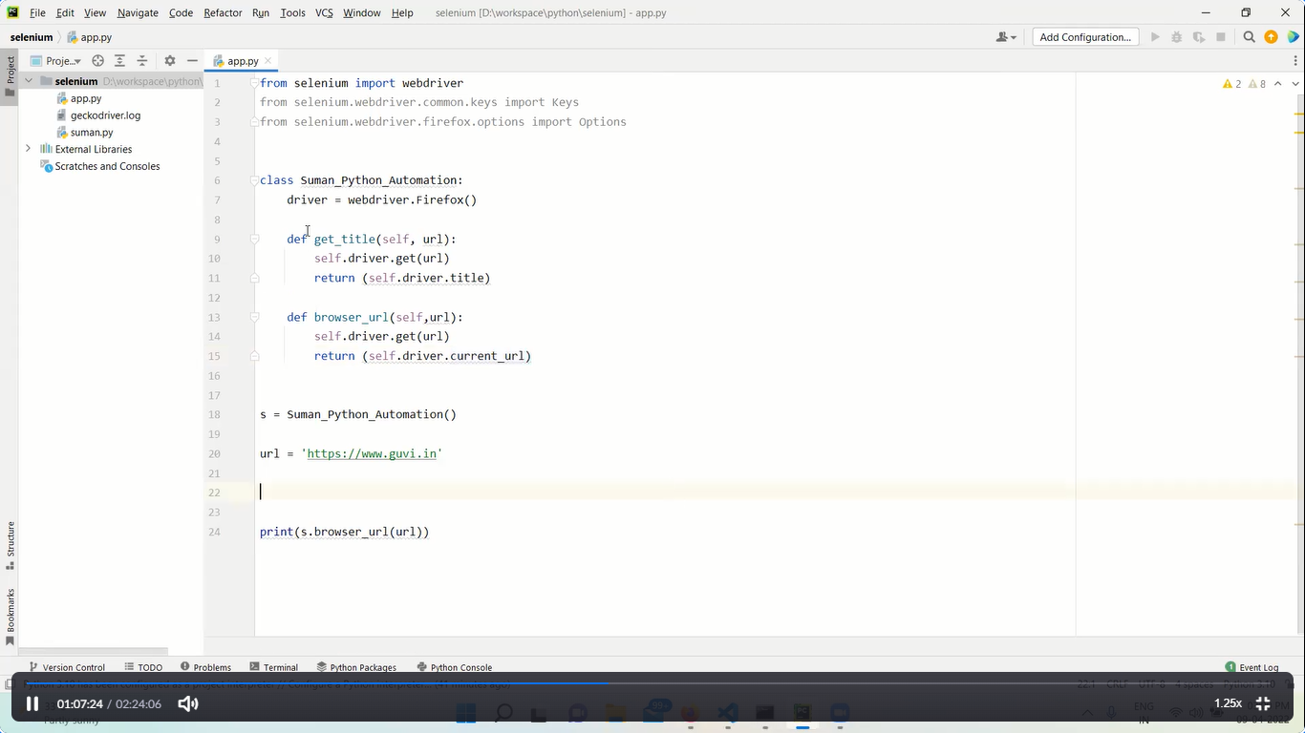

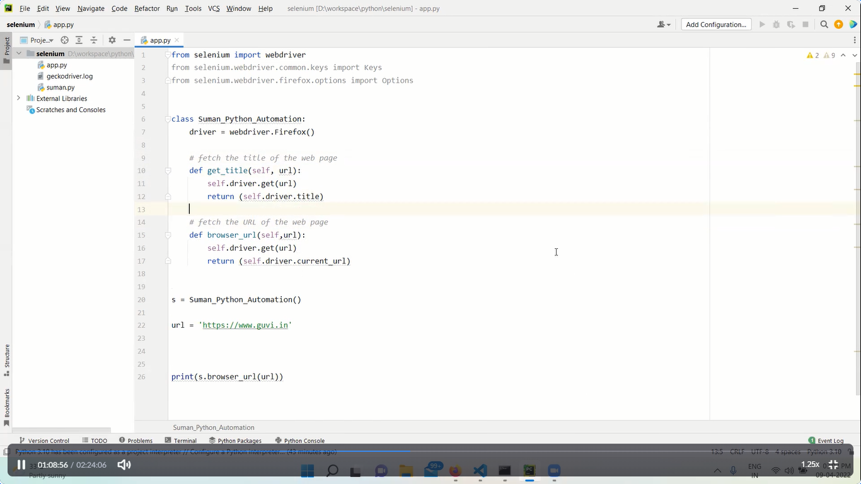

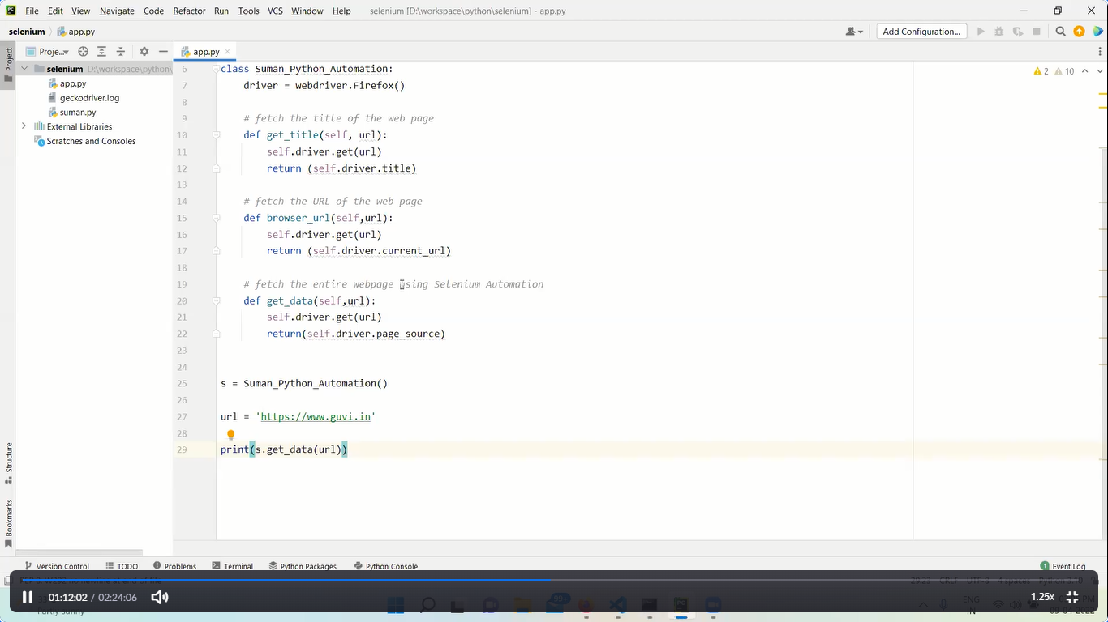

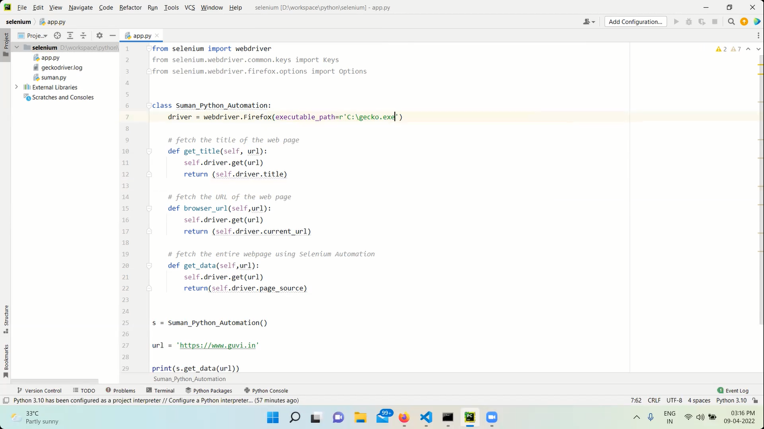

**HEADLESS BROWSER**

* A headless browser is a browser that runs like a normal browser but without any GUI of a real browser.
* It runs from the command-prompt itself.
* It is used for automation and testing purpose only
* Also used for hacking like DDOS attacks.

**CLASS TASK**

Using Python Selenium extarct the entire content of the https://www.guvi.in and save in atext file ?

